**Concordia University**

**SOEN 6611**

**SOFTWARE MEASUREMENT**

**Team Members:**

Asifali Dauva: 6756239

Ankita Mishra: 6776973

Nikita Parashar: 6766994

Pradeep Samuel: 6934153

# Extracting Attributes

# Relation : Release_Info

## Attributes

1. OS: Target platform of the Project. Required to distinguish the project versions developed for different platforms.
2. CHANNEL: Phase (or Name) of the release (e.g. stable, beta, canary etc.). Required to identify the phase of the different versions of the project e.g. Version (40) for (Windows) in Phase (Beta).
3. MAJOR_VERSION: Version number of the project release. Required to distinguish between different major versions of the project for each platform.
4. RELEASE_DATE: Release date of the major versions of the project. Required to measure the difference (time gap) between the release dates of 2 different versions of the project.

# Relation : BUG_INFO

## Attributes

1. ISSUE_ID: The unique id for each bug reported. Required to identify and fetch reviews conducted for the bug.
2. MILESTONE: Version number of the project in which this bug is supposed to be fixed and released . Required to calculate the number of bugs in a particular milestone (or version) of the project.
3. STATUS: Identify the status of the bug. Required to distinguish between fixed and not fixed bugs.
4. OS: Indicates the platform of the project for which the bug is reported. Required to calculate the number of bugs in particular versions of the project for particular platform.
5. START_DATE: Indicates the bug reporting time. Required in some cases to compute missing attributes of the bug end date.
6. END_DATE: Indicates the date on which the bug is closed. Required to compute the bug block time and in some cases the code review time.
7. BLOCKED: Indicates if the bug is blocked because of some other bug. Required to calculate bug block time.

# Relation : REVIEW_INFO

## Attributes

1. REVIEW_ID: The unique id for each review started. Required to identify and fetch reviews conducted for the bug.
2. BUG_ID: Id of the bug for which the review is conducted. Required to identify and access more information (other attributes) of the bug.
3. START_DATE: Indicates the start time of the review. Required to calculate the code review time.
4. LAST_MODIFIED_DATE: Indicates the last date on which the review is modified (closed). Required to calculate the code review time and bug blocking time.
5. BUG_BLOCKED_TIME: Indicates the time for which the bug was blocked from being released. Required to compute the total blocking time of bugs in a particular version of the project.

# Linking Attributes

# Relationship : Release_Info -> Bug_Info

## Description

Release_Info is related to Bug_Info via attributes Milestone and OS. Each bug in Bug_Info is associated with a Milestone (project version or release) in which it is supposed to be fixed and released and the OS i.e. the corresponding platform of the project. By linking bugs with release info we can calculate the number of bugs in each release (or milestone) of the project for each platform.

# Relationship : Bug_Info -> Review_Info

## Description

Bug_Info is related to Review_Info via attributes Bug_Id. Each review is associated with a bug id corresponding to the bug for which it is created. By linking reviews with bugs we can calculate the bug code review time and bug blocking time.

# Relationship : Release_Info -> Bug_Info -> Review_Info

## Description

Release_Info, Bug_Info and Review_Info are related by (OS and Milestone) and (Bug_id) correspondingly. Each milestone (or release) of a Project for a particular platform has bugs on which code reviews have been performed. By linking all 3 tables together we can calculate the release time gap between release of major versions (or releases) of the project for each platform, total number of bugs in the release, code review time for the bugs in the release and total blocking time of bugs in the release.

# Schema Diagram

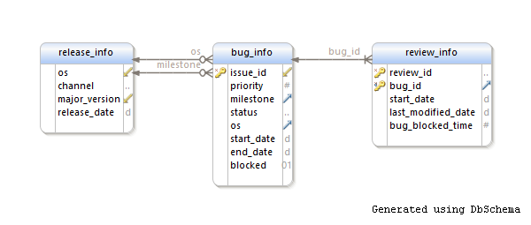

# Summary Relation

# Relation : Summary_Info

|  |  |
| --- | --- |
| Attributes | Scale |
| OS | **Nominal** |
| Release | **Ordinal** |
| Previous_Release | **Ordinal** |
| Release_Time_Gap | **Interval** |
| Number_Of_Bugs | **Absolute** |
| Code_Review_Time | **Interval** |
| Total_Blocked_Time | **Interval** |